

FACULTY OF INFORMATION & COMMUNICATION TECHNOLOGY

SEMESTER 1 SESSION 2020/2021

BITI3533 ARTIFICIAL INTELIGENCE PROJECT MANAGEMENT

FIRE DETECTION USING COMPUTER VISION

LAB 8

AOA & AON NETWORK

Prepared for:

PROF. TS. DR. GOH ONG SING

Prepared by:

|  |  |  |
| --- | --- | --- |
| **NAME** | **MATRIC NO.** | **PROGRAMME** |
| NUR IZZATI BINTI SHAFIE | B031910476 | BITI |
| NUR’AIN NAJIHA BINTI ZAKARIA | B031910466 | BITI |
| MEGALA D/O SONTULOM | B031910172 | BITI |

26th NOVEMBER 2020

Lab 8- AOA & AON NETWORK

1. Based on your proposed AIProject, draw your Gantt chart with your timeline, milestone and description as given example at the Figure 1.

The Gantt charts should provide a standard format for displaying project schedule information by listing project activities and their corresponding start and finish dates in a calendar format include following Symbols:

* + Black diamonds: Milestones
  + Thick black bars: Summary tasks
  + Lighter horizontal bars: Durations of tasks
  + Arrows: Dependencies between tasks

**GANTT CHART**

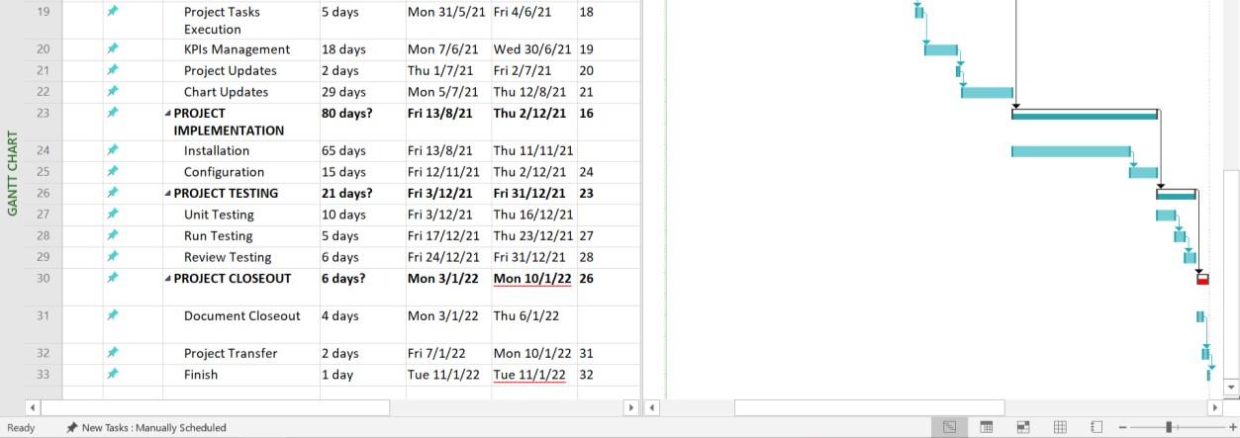

**Figure 1: Gantt Chart**

1. Identify each path Fire Detection Using Computer Vision project in Figure 1 and determine the Critical Path for Fire Detection Using Computer Vision Project.

**TABLE**

|  |  |  |
| --- | --- | --- |
| **Activity/ Tasks** | **Predecessors** | **Duration** |
| A = Project Initiation | - | 99 |
| B = Project Planning | 2 | 38 |
| C = Project Execution | 10 | 60 |
| D = Project Implementation | 16 | 80 |
| E = Project Testing | 23 | 21 |
| F = Project Closeout | 26 | 6 |

**Note:**

**Assume all durations are in days**

**.**

A

F

D

E

C

B

99

38

80

6

60

21

**Figure 2: Fire Detection Using Computer Vision Project**

**Path 1**: A-B-D-F , Length = 99+38+80+6 = 223 days

**Path 2**: A-B-E-F , Length = 99+38+21+6 = 164 days

**Path 3**: A-C-E-F , Length = 99+60+21+6 = 186 days

* **The critical path is the longest path. So, the path 1 is the Critical Path for Fire Detection Using Computer Vision Project. Because it takes 223 days.**